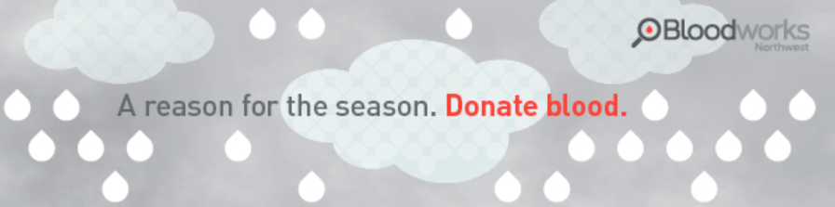

With covid-19, cold and flu season, the holiday season AND the anticipation of potential snowy Winter Weather, blood donations are needed more than ever!

Key Club at Chief Sealth High School understands this need and will host a two-week virtual drive from Sun Dec 20 to Sun Jan 3 to help ensure an ample blood supply for our community over this time frame.

Here is how you can help!
- Visit www.bloodworksnw.org/donate and find a donor center or pop-up center near you.

- Book your donation appointment online NOW to donate between Dec 20 to Jan 3

- Arrive for your appointment and let the person registering (checking you in) know you are donating on behalf of Key Club at Chief Sealth High School and provide donor code 688B so we can track the impact of key clubs recruitment efforts! The goal is to find 35 folks to attend over the two week time frame!

As an added perk, through Dec 31, all donors will automatically be tested for covid-19 antibodies. Results mailed within 2 weeks of your donation.

Have questions or need help booking an appointment? Please call 1-800-398-7888 or e-mail schedule@bloodworksnw.org

Giving blood during the pandemic is a safe and essential action. For more info on how Bloodworks is keeping donors and staff safe, by abiding by all CDC, FDA and WA State Department of Health guidelines please visit: https://www.bloodworksnw.org/about/news/coronavirus

To ensure social distancing at pop-ups and centers, appointments are required. Walk-ins, guests or anyone under 16 years of age are (unfortunately) not permitted. Face masks required.

The permission for minors form (required for all 16 and 17 year old first time donors) can be found at www.bloodworksnw.org

